**Lab 02**

1. Considering a project as a sample, design user interface screens using graphical interface.

2. Comparison of Command line versus Graphical Interface. You are required to design TWO interaction screens, one without using graphical interface, text boxes, combo boxes etc. and one using icons, text boxes, lists etc. The second version should clearly indicate advantages of graphical interface

**COMMAND LINE INTERFACE:**

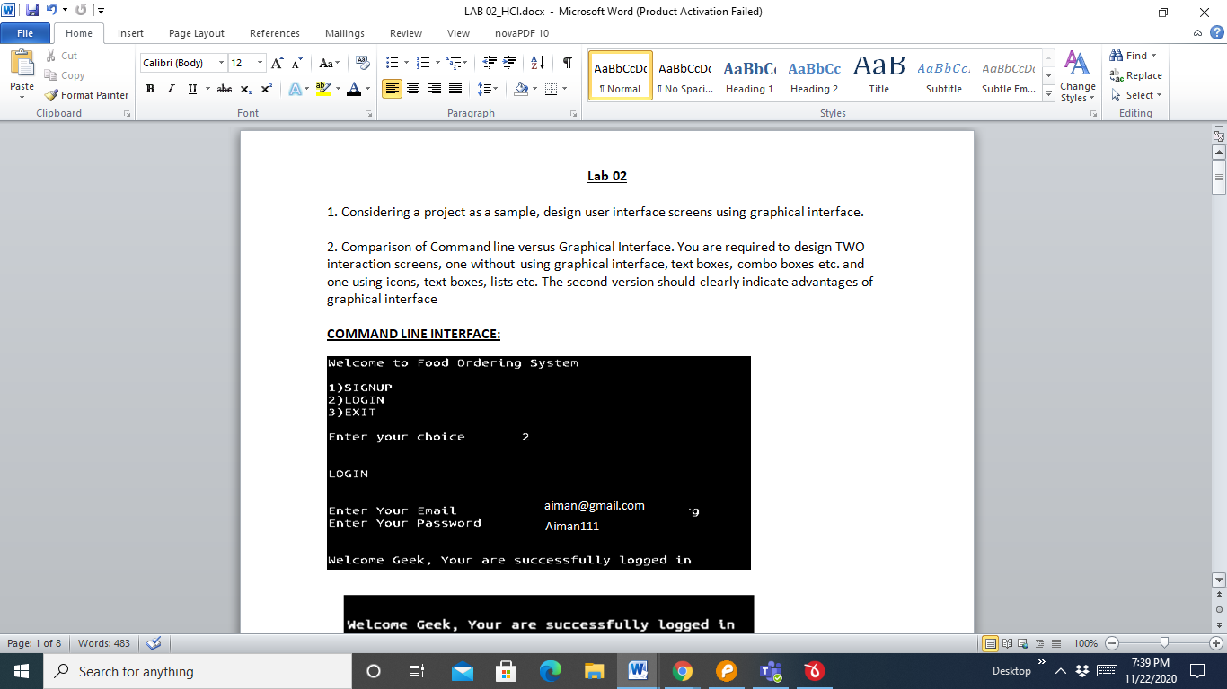

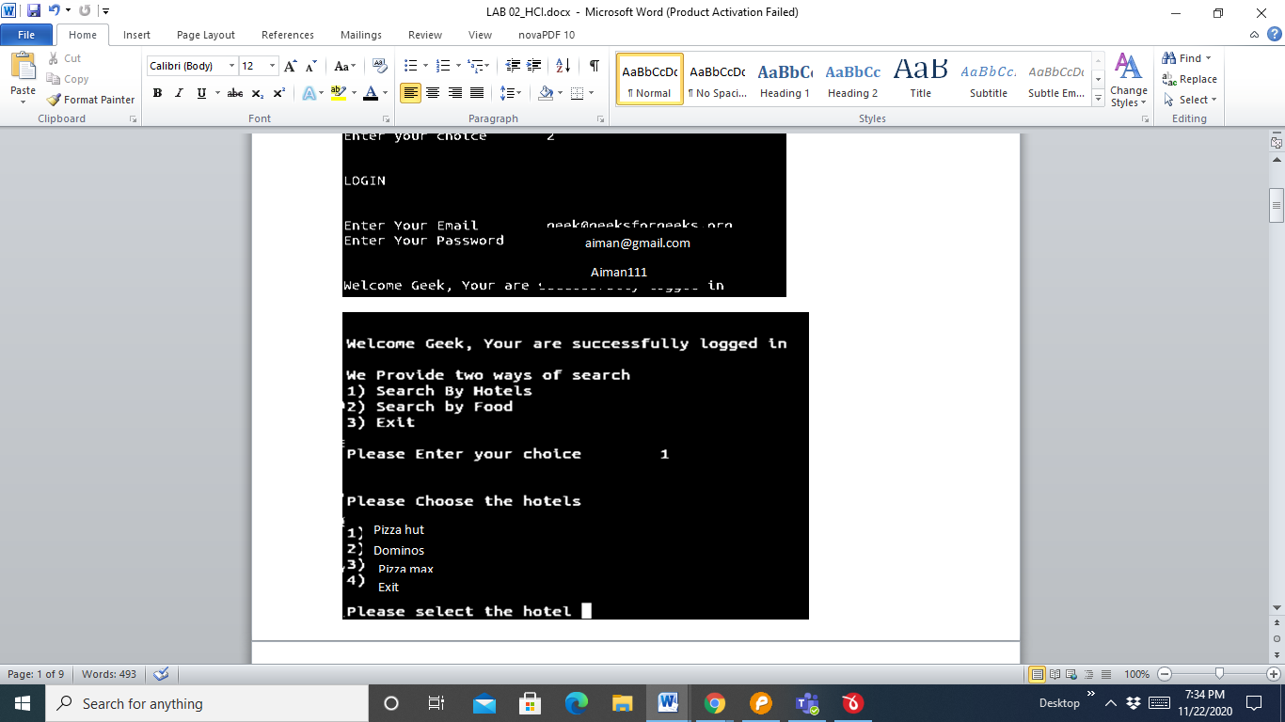

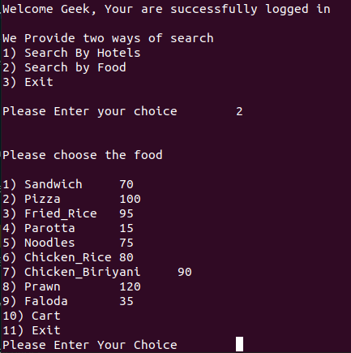

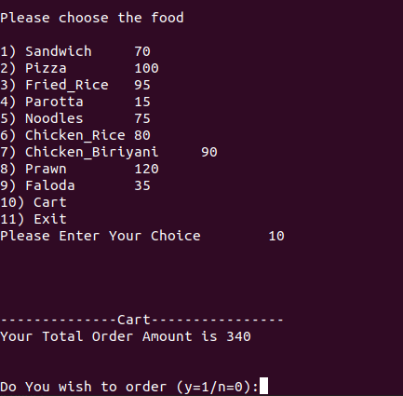

**GRAPHICAL USER INTERFACE:**

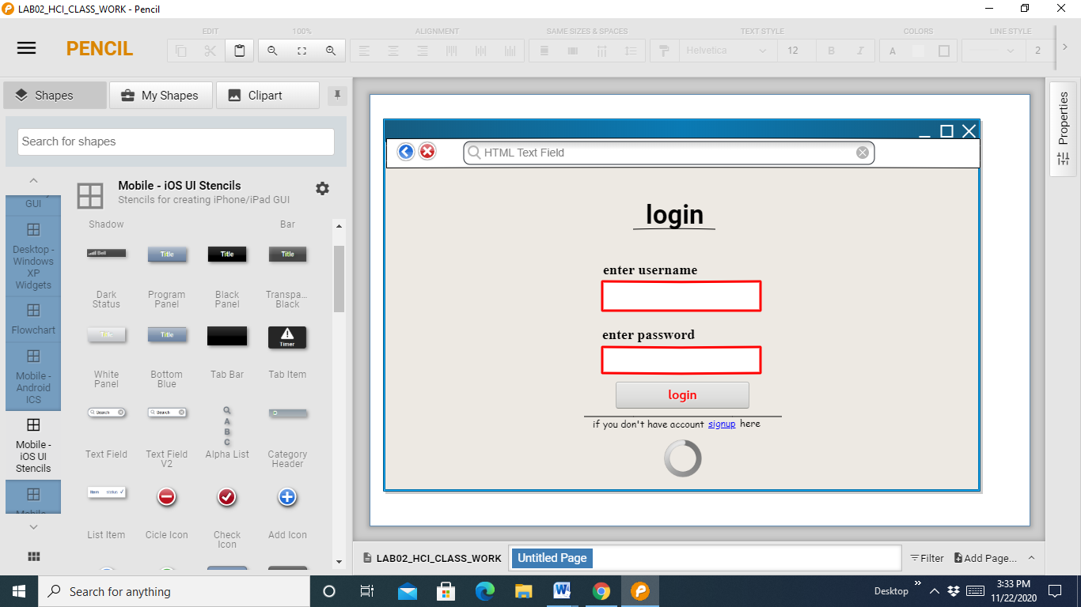

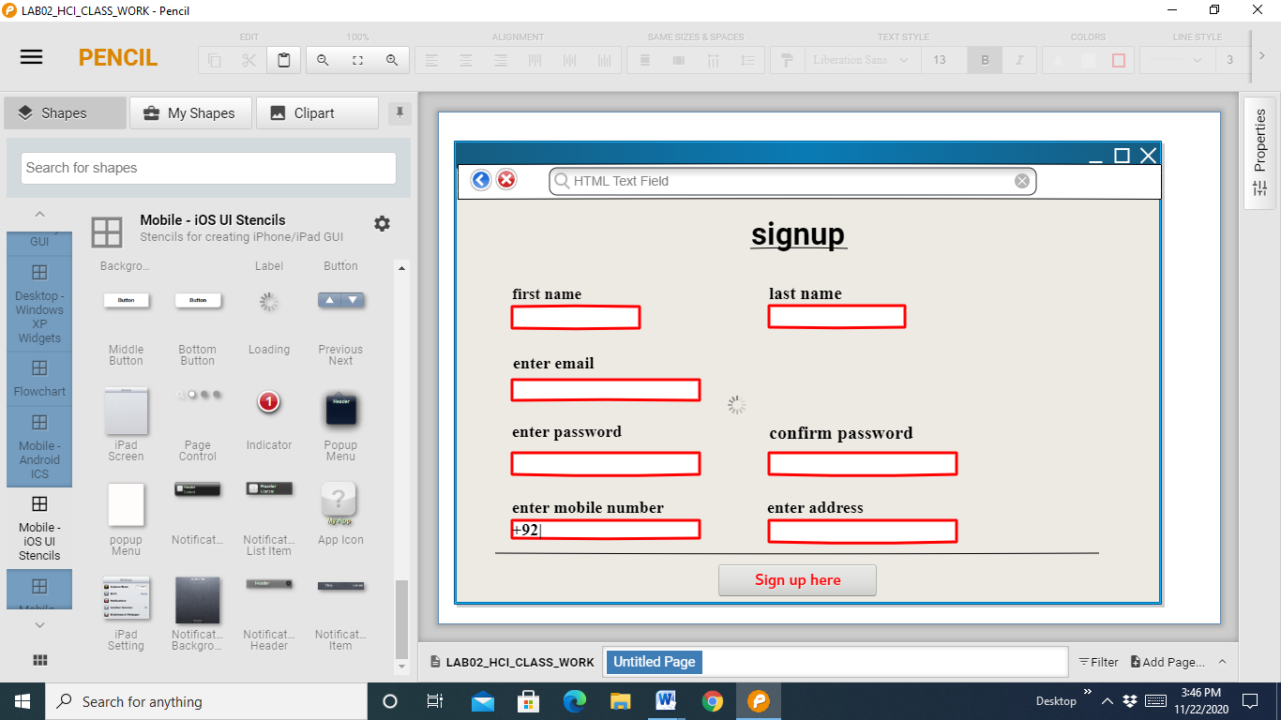



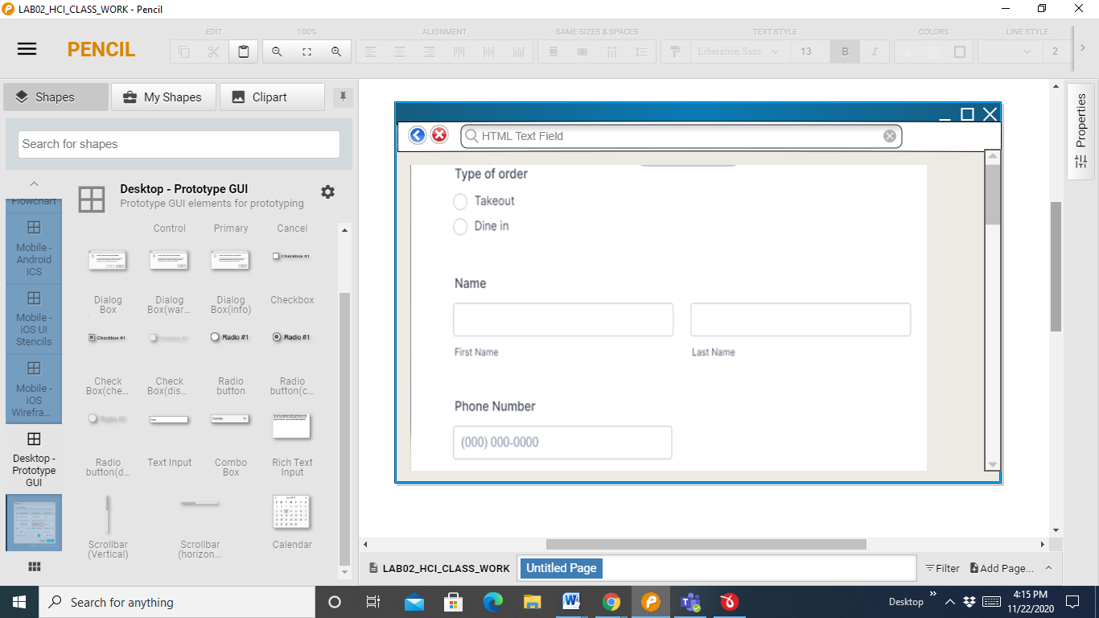

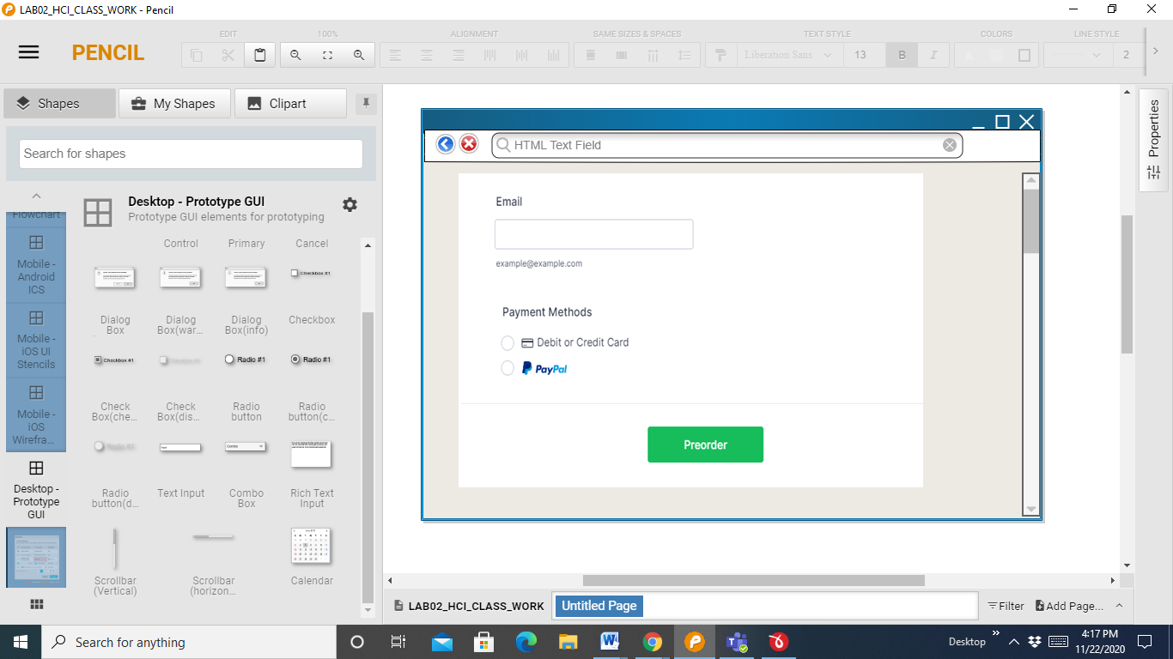

3. The conclusion should include answers of the questions:

a) Advantages of Graphical Interfaces?

b) Limitations of Graphical interfaces?

**ANSWERS:**

a) Advantages of Graphical Interfaces?

**Advantages of graphical user interface:-**

1. **Easiness for non-technical people:-**

For non-technical people or for beginners good GUI’s tends to make easiness in life. For example with few clicks on buttons user can easily make his work done.

1. **Drag and drop feature:-**

In most of the software, we have drag and drop functionality by which complex tasks are managed easily.

1. **Looks nicer than text interface:-**

For non-educated people, text interface is difficult to understand and use. In GUI user can use any tool by detecting symbols or buttons.

1. **Hotkeys usage:-**

Sometimes we want a couple of functionality performed by single click then we use hotkeys.

1. **User-friendly:-**

A user can easily navigate to the system without knowing a lot of details. Easy setup and ready to start working are awesome.

1. **Disabled people:-**

In modern science, we can detect eyes movement and finger movement which is helpful for disabled people. Now, most of the software uses this functionality to make life easier for disabled people.

b) Limitations of Graphical interfaces?

**Disadvantages of graphical user interface:-**

1. **Difficult to develop and high cost:-**

Nice looking designs are difficult to make and may also cost extra hardware support. Like high-quality games consume a lot of device space and memory and it also required very skilled people to develop.

1. **Using flat screen:-**

Some graphical things do not display accurately on flat screens. In airplanes, sticks are used to control most of the things because flat screen display is not very handy. This makes the limitation of GUI.

1. **Time consumption:-**

It takes a lot of time to develop and design a good looking interface. If some bad interface builds then it makes difficult for the user to understand and use.

1. **Memory resources:-**

I see a lot of good GUI’s consuming lot of memory resources which make system/device slow to perform.

1. **Implementation:-**

Testing and implementation take a lot of time. Like we may require extra software for running GUI’s